Food Management System

Use-Case-Realization Specification: Add Product

Version <1.0>

Revision History

|  |  |  |  |
| --- | --- | --- | --- |
| **Date** | **Version** | **Description** | **Author** |
| <24/12/2020> | <1.1> | Final Draft | Nguyen Thi Ngoc Anh |

Table of Contents

1. Introduction 2

1.1 Purpose 2

1.2 Scope 2

1.3 Definitions, Acronyms, and Abbreviations 2

1.4 References 2

1.5 Overview 2

2. Flow of Events—Design 2

3. Derived Requirements 2

Use-Case-Realization Specification: Add Product

# Introduction

## Purpose

This document describes how the Add Product Use-Case is realized within the design model, in terms of collaborating objects.

## Scope

This document applies to the Food Management System which will be developed by TAT Restaurant.

## Definitions, Acronyms, and Abbreviations

None.

## References

None.

## Overview

In the following section, Use-Case Realization Specification of the Add Product Use-Case of the Food Management System is provided in detail. The first section is a textual description of the Use-Case specification. The following section contains diagrams (sequence and collaboration diagrams) describing how the use case is realized in terms of collaborating objects. The third section includes class diagrams with relationships that participate in the realization of the use case. The last section is an analysis of all requirements, such as non-functional requirements, on the use-case realization that are not considered in the design model, but that need to be taken care of during implementation.

# Flow of Events—Design

**2.1. Use Case Specification (script)**

|  |  |
| --- | --- |
| **Use Case** | Add Product |
| **Description** | Admin adds new product(s) to the database |
| **Actor(s)** | Admin |
| **Flows of Events** |  |
| **Basic Flow** | |
| 1. The user goes to add products page.  2. The user enters information for a new product  3. The user submits information.  4. The system verifies information, and save the new product with specified information to database | |
| **Alternative Flows** | |
| **Title** | **Description** |
| Invalid Information Entered | 1. User enter invalid information.  2. System displays information with appropriate message to correct invalid information. |
| **Pre-conditions** | |
| The user is logged in. | |
| **Post-conditions** | |
| **Title** | **Description** |
| Success | Success message is prompted and the product with specified information is added to database. |
| Failure | The user is unable to add new product to database for one or more reasons and an error is prompt. |
| **Extension Points** | |
| None. | |

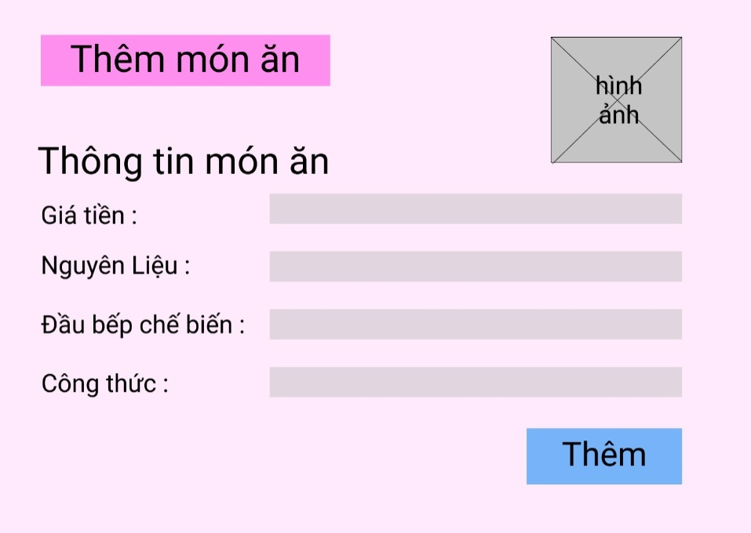

**2.2. Sequence Diagram:**

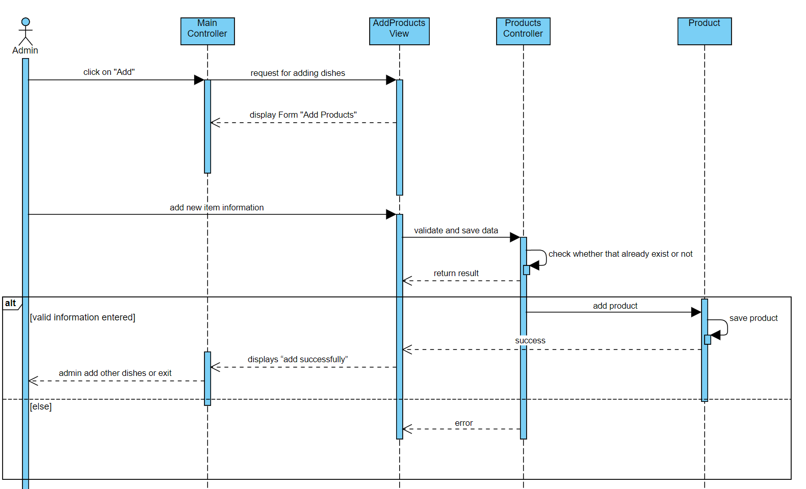

**2.3. Class Diagram:**

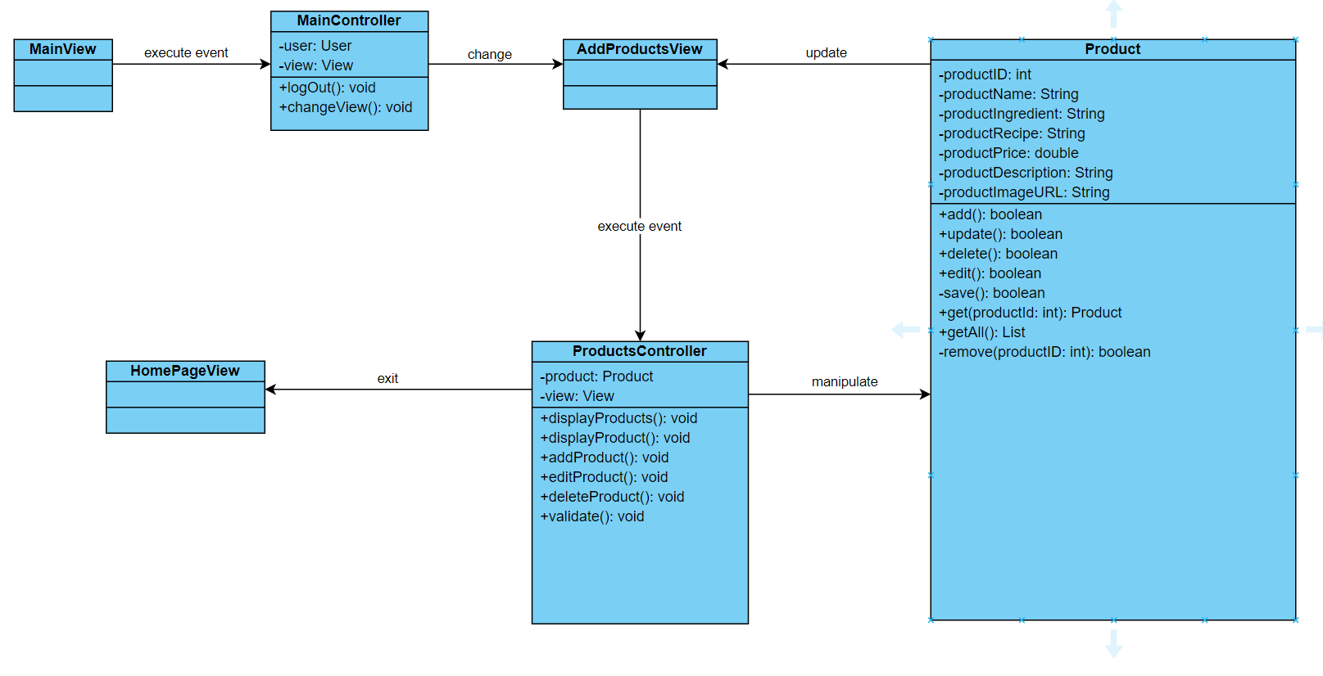

# Derived Requirements

None.